**How to test version 2:**

Yolo algorithm is used to detect poth holes.

You Only Look Once (YOLO) You Only Look Once (YOLO) is one of the most popular model architectures and object detection algorithms. It uses one of the best neural network architectures **to produce high accuracy and overall processing speed**, which is the main reason for its popularity.

Here is a comparison of how efficient yolo works:

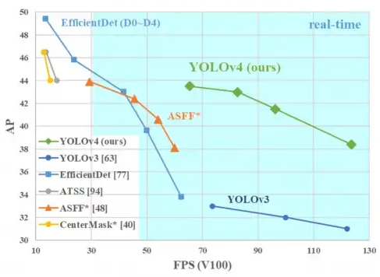

Here FPS is frames per second and AP is average precision.

We need machine learning algorithm because finding the potholes based on difference can lead to wrong evaluations as road might have other debri and can be concluded as potholes.

**Step 1**: Go to potholeDetectPiCamSchedule.py and open it in thonny.

**Step 2: U**pdate the values i.e sender email, reciever’s email and password.

The passoword should be the one generated as shown in the [Raspberry pi Set up email API.docx](https://github.com/skillplot/cs-g518-iot/blob/main/projects/sem-1-2022-23/Project_KSKumar/Version2/Docs/Raspberry pi Set up email API.docx)

**Step 3:** Update the paths for yolo weights and config file. The complete paths should be mentioned as these would be executed from the terminal.

**Step 4:** To run it on start up, the following steps are to be followed.

**Step 5:**

run the program normally and see if it is working.

eg: python3 /home/pi/pothole-detectionTest/test.py

now use the following command:

sudo crontab -e

**Step 6:** You will get following options:

Select an editor. To change later, run 'select-editor'.

1. /bin/nano <---- easiest

2. /usr/bin/vim.tiny

3. /usr/bin/code

4. /bin/ed

Choose 1-4 [1]:

**Step 7:**

choose 1

go to end of the file and click enter

type:

@reboot python3 /home/pi/pothole-detectionTest/potholeDetectPiCamSchedule.py &

ctrl s

ctrl x

**Step 8:**

/home/pi/.config/lxsession/LXDE-pi/autostart

**Step 9:**

To check the output on local desktop uncomment imshow method in the code.

Here is a sample input file



Here is the sample output file:

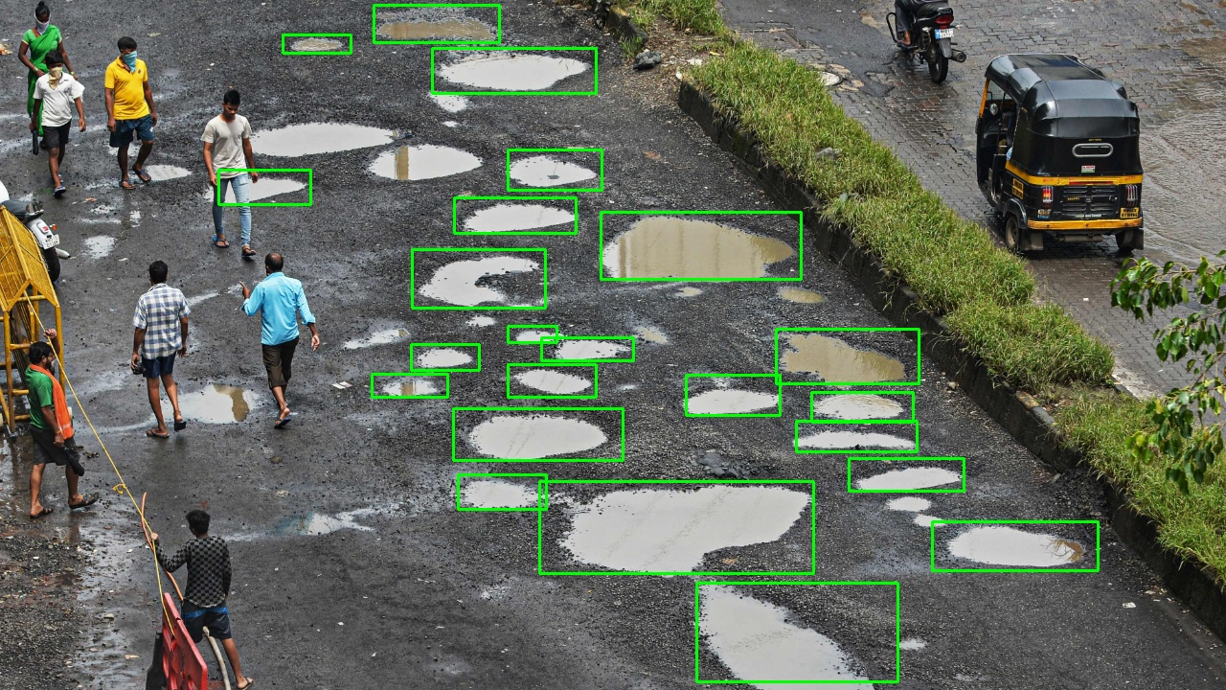

Only potholes are detected, the rest are ignored.

Now run in terminal as shown in the previous step.

Output(mail):

